JAVA DOCUMENTATION

PROJECT 2 DOCUMENTATION
Project Name
Student Grade Calculator
Objective
The objective of this project is to develop a Java application that calculates the total marks, average percentage, and grade of a student based on marks obtained in multiple subjects. The program also determines the student's performance using a grading system.
Introduction
The Student Grade Calculator is a Java-based application designed to automate the process of calculating academic results. It accepts marks for multiple subjects, computes the total and average percentage, and assigns an appropriate grade based on the calculated percentage. This project demonstrates the use of arithmetic operations, loops, and conditional statements in Java.
Tools and Technologies Used
- Java
- JDK (Java Development Kit)
- VS Code / IntelliJ IDEA
- Scanner Class
Key Features
- Accepts marks for multiple subjects
- Calculates total marks
- Calculates average percentage
- Assigns grades automatically
- Displays result in a clear format
- Input validation for marks
- Pass/Fail indication
Algorithm
- Start the program.
- Read the student's name.
- Read the number of subjects.
- Accept marks for each subject.
- Validate marks entered by the user.
- Calculate total marks.
- Calculate average percentage.
- Determine grade based on percentage.
- Determine pass or fail status.
- Display the final report card.
- End the program.
Concepts Used
- Variables
- Loops (for loop)
- Conditional Statements (if-else)
- Arithmetic Operations
- User Input Handling
- Percentage Calculation
Grading Criteria
- A+ : 90% and above
- A : 80% to 89%
- B : 70% to 79%
- C : 60% to 69%
- D : 50% to 59%
- F : Below 50%
Output Screenshot
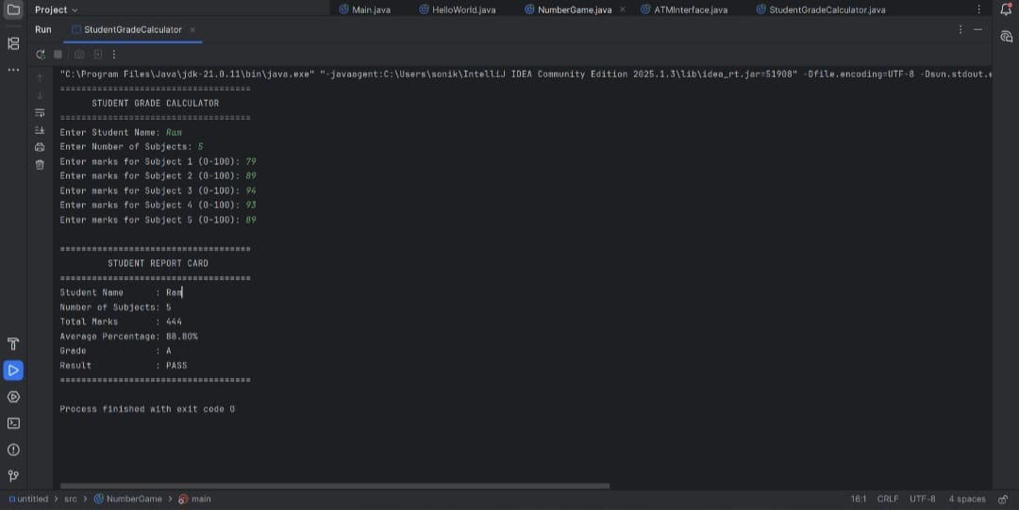
Advantages
- Reduces manual calculation errors
- Fast and accurate result generation
- Easy to use
- Demonstrates core Java programming concepts
- Suitable for educational applications
Conclusion
The Student Grade Calculator was successfully developed using Java. The project accurately calculates total marks, percentage, grades, and pass/fail status. It demonstrates the practical implementation of loops, arithmetic operations, conditional statements, and user input handling, making it an excellent beginner-level Java project.

